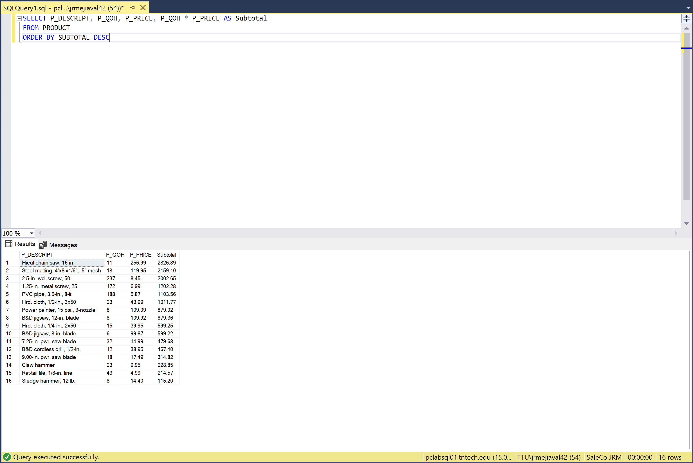SaleCo.

Out of Class Assignment 9-10-21

1. Create a query to produce the total purchase per invoice, generating the results shown below, sorted by invoice number. The invoice total is the sum of the product purchases in the LINE that corresponds to the INVOICE.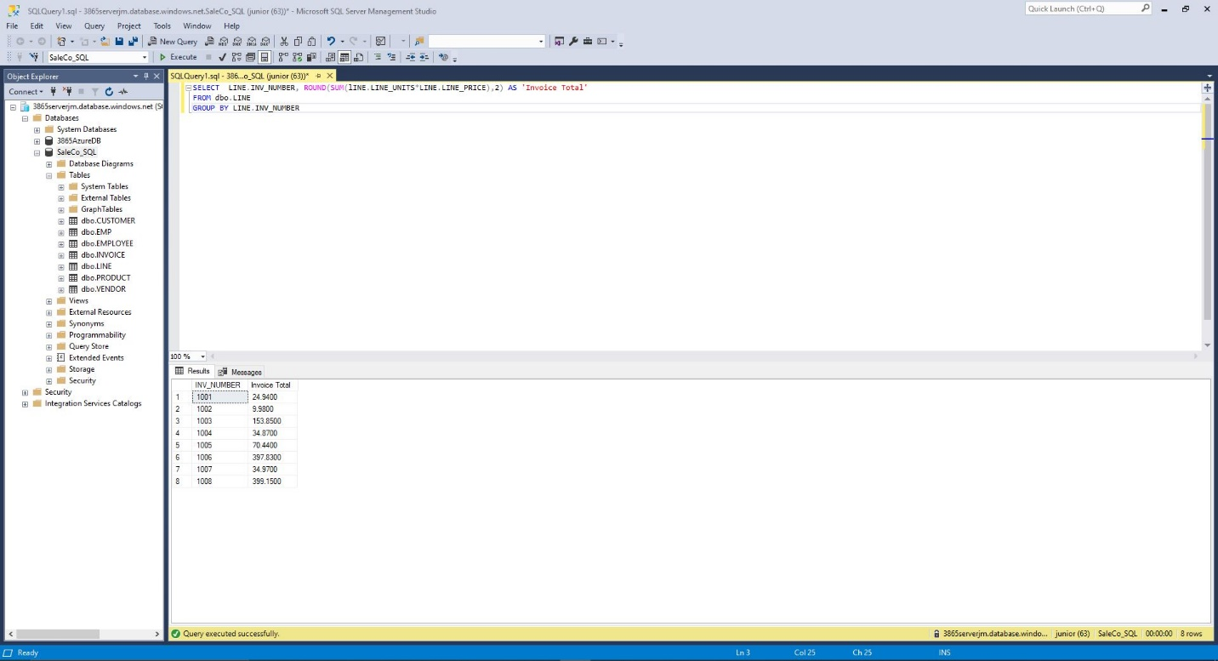
2. Find the total value of the product inventory. The results are shown below.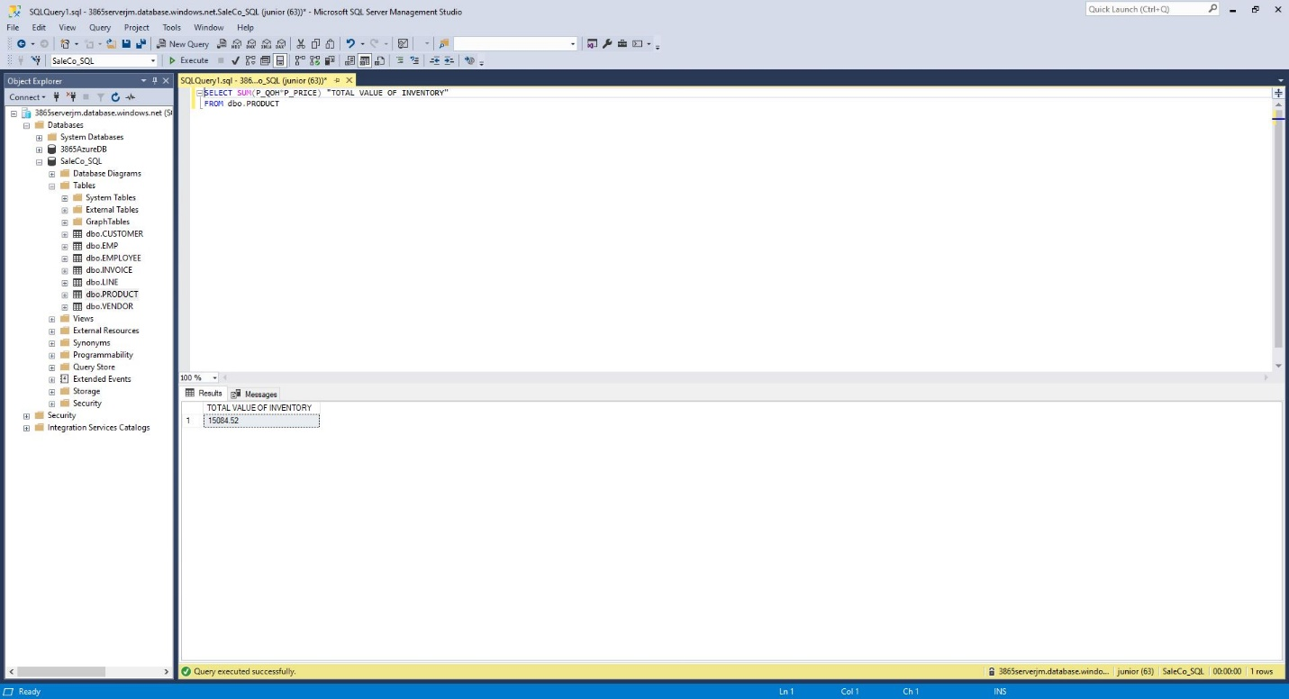
3. Find the total value of the product inventory. The results are shown below.